Bryant Hayes, Bryan Bowman, Taylor Rawlings

April 4, 2016

Group Design Concept Proposal

## Design Concepts & Brainstorming

Our design has three primary parts: a robotic arm for acting on the environment, a single camera for getting information about the environment, and the mechanical structure for maintaining a stable foundation for the other two parts. This breakdown shows that all three disciplines (ECE, CS & ME).

The Robotic Arm

The arm will be what interacts with the environment and holds the fishing rod. The arm will be a palletizing robotic arm design with 300mm total reach. The arm movement will be driven using three standard sized servomotors (MG996R) all located at the base of the arm. We will use cheaper servos to start, and upgrade if the need for more torque or speed arises. The arm will give us motion in the X, Y and Z directions and must be able to put the tip of the fishing rod on any part of our half of the playing field. We also will need to make sure that it is steady enough when idling so that there is not significant swing in the fishing rod. We will develop a library that makes it simple to input a 3D location in space, or on the board, and have the arm go to that position in the shortest time. The movement algorithms will be encapsulated in this class and will not need to be altered once established. The arm’s servos will receive commands from an Intel Edison microprocessor over PWM signals. The servos will be powered from a separate 7V 8A power source, which comes from a 12V 60W wall wart, stepped down to 7V with about 81% efficiency. The control scheme to actually move the arm will come from a computer connected to the Arduino board via Serial. The movements will be based on information gathered from the machine vision system.

Machine Vision System

The machine vision system will use a Cognex In-Sight 7000 camera that will enable us to offload a lot of the processing to the camera itself. We are not yet sure of the capabilities of this internal processing, but in general the job of the camera system will be to scan the playing field and help determine which key points on the board that we should fish. Once detecting these points, commands will be sent from the laptop to the Intel Edison board, eventually resulting in movement of the robotic arm.

Mechanical Structure

The robot’s body will be made of metal and will allow for a rigid connection to the robotic arm base as well as a tower component that will hold the machine vision camera. Along the base there will be some kind of sensors or marks that insure the robot is aligned correctly in relation to the board game. A panel in the rear of the robot will contain all electronics and circuit boards mounted with spacers. The main input to the system will be the 12V 60W wall wart, but besides that our goal is to make it small-medium sized, sturdy and very portable.

## Functional Goals

* Know the orientation of game board after initialization phase.
* Be able to easily send movement commands from the laptop to the Intel Edison, which in turn control the robotic arm.
* Have little to no jitter in the robotic arm, and have smooth motion when moving.
* Be able to pick up as well as drop a fish with at least 50% accuracy (Fish is successfully grabbed at least every two attempts)
* Be able to sense if a fish is hooked

## Sketch of System

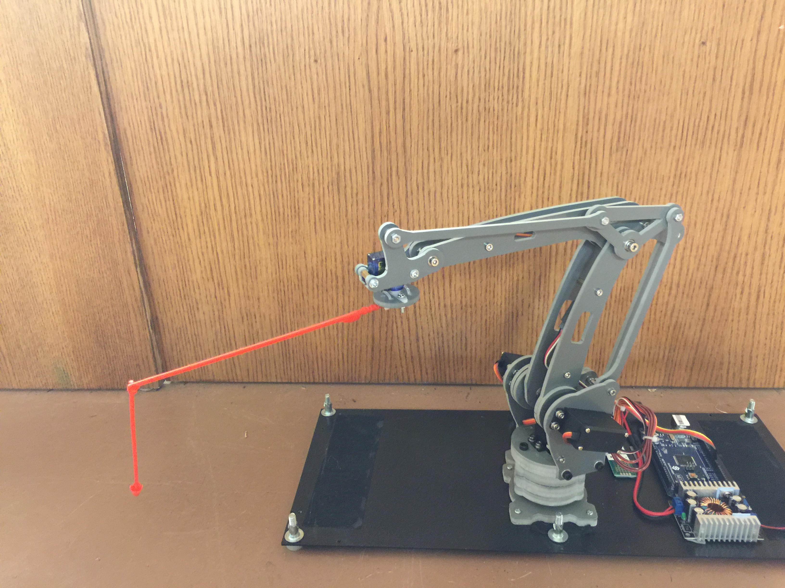

## Macintosh HD:Users:bryanthayes:Downloads:FLOWCHART-2.pngFlowchart of Functions

## Block Diagram

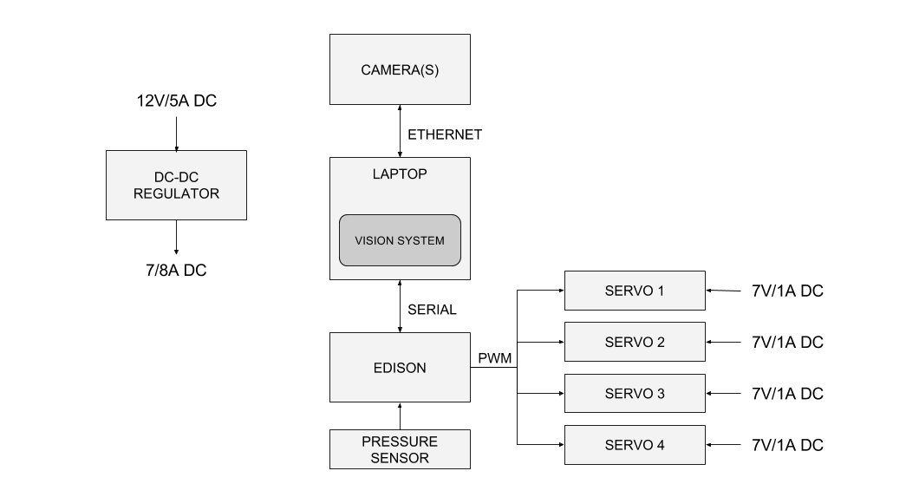

## Team Responsibilities

Bryant’s primary role in the project will be the programming of the robotic arm algorithms, the machine vision algorithms and the communication protocols between the laptop and the Intel Edison

Bryan’s primary tasks will be wiring of the servos, breakout boards and any miscellaneous tasks associated with electrical work.

Taylor’s responsibilities will overall structure design, CAD drawings, rod holder development, and all other mechanical issues that arise.

## Timeline

